

**Names**: Ngabonziza Fiston

**Student Id:** 26857

**Date:** 14th December2023

**Course code:** INSY412 Web Technology and Internet

**TOPIC:   
Ubudehe MANAGEMENT STYSTEM**

The Ubudehe Management System is a streamlined software ensuring efficient, fair, and secure registration for Ubudehe participation. Prioritizing accuracy, it automates processes, maintains data integrity, and upholds confidentiality. Its goal is to enroll qualified individuals effectively, contributing to a robust citizen management framework.

**Ngabonziza Fiston**

ngabofiston23@gmail.com

Table of Contents

Ubudehe Management System 2

I. Introduction 2

1.2 Goals 2

1.3 System Scope 2

13.1. Accuracy Priority 3

1.3.2 .Enhanced Applicant Experience 3

1.3.3. Security Measures 3

1.3.4. System's Objective 3

1.4. Screenshot about all system shows how it works 4

*1.4.1. Figure: Home page* 4

*1.4.2. Figure: dashboard* 5

*1.4.3. Figure: Create account* 6

*1.4.4. Figure: SignUp* 7

*1.4.5. Figure: Login* 8

*1.4.5. Figure: Register citizen* 9

*1.4.5. Figure: Upload file* 10

*1.4.5. Figure: View users* 11

1.5 Conclusion 12

# Ubudehe Management System

# I. Introduction

An Ubudehe management system is a software solution crafted to streamline and automate the registration process for individuals aspiring to join Ubudehe. It operates as a centralized platform facilitating efficient management from application to enrollment.

# 1.2 Goals

Efficiency and Promptness: The system aims to expedite registration by minimizing paperwork, automating data collection, and eradicating manual errors, ensuring a swift and smooth process for applicants.

Precision and Data Validity: Ensuring accurate and trustworthy records of applicant information is the primary aim. The system seeks to validate and authenticate applicant-provided documents and qualifications to ensure the registration process's integrity.

Standardization and Uniformity: Establishing uniform procedures and criteria for registration across various Ubudehe regions or branches is key. This ensures fairness and equal opportunities for all applicants, eliminating disparities.

Security and Confidentiality: Upholding the utmost security and confidentiality of applicant data is paramount. The system strives to implement strong security measures to prevent unauthorized access or breaches, safeguarding personal and sensitive information.

# 1.3 System Scope

The Ubudehe management system ensures efficient and standardized handling of applicant information across diverse Ubudehe regions or branches.

## 13.1. Accuracy Priority

The system gives priority to accuracy and data integrity to uphold reliable applicant records and authenticate submitted documents.

## 1.3.2 .Enhanced Applicant Experience

Simplifying the registration process, providing clear instructions, and offering support throughout registration stages are all aimed at improving the overall applicant experience.

## 1.3.3. Security Measures

Protecting applicant data's security and confidentiality is of utmost importance, with robust measures in place to prevent unauthorized access or breaches.

## 1.3.4. System's Objective

The Ubudehe Registration System aims to efficiently register and enlist qualified individuals for appropriate Ubudehe roles, contributing to effective Citizen Management.

# 1.4. Screenshot about all system shows how it works

## *1.4.1. Figure: Home page*



## *1.4.2. Figure: dashboard*



## *1.4.3. Figure: Create account*



## *1.4.4. Figure: SignUp*



## *1.4.5. Figure: Login*



## *1.4.5. Figure: Register citizen*



## *1.4.5. Figure: Upload file*



## *1.4.5. Figure: View users*

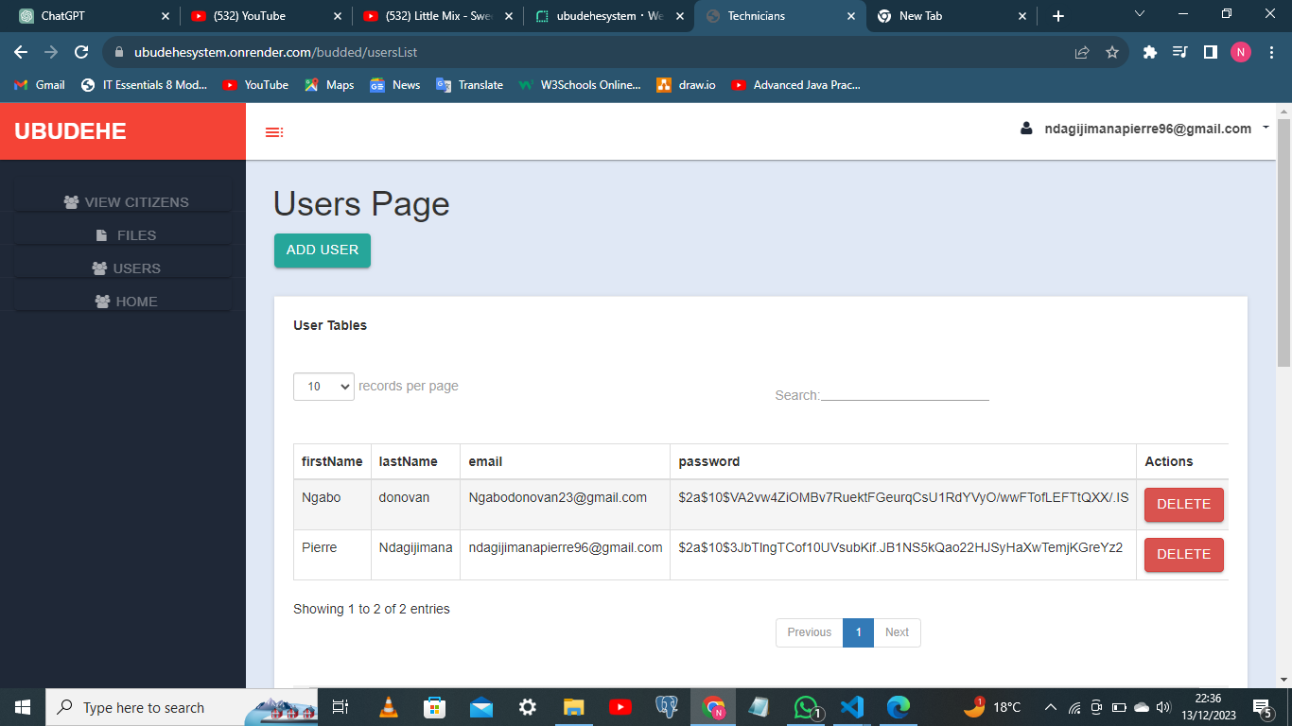

# 1.5 Conclusion

The Ubudehe Management System stands as a pivotal solution, revolutionizing the registration process for aspiring participants. By amalgamating efficiency, accuracy, and security, it heralds a new era of streamlined operations.

Its core objectives encompass expediting registrations through minimized paperwork and automated processes, ensuring data accuracy and integrity via stringent validation measures, and establishing uniform standards across Ubudehe branches for fairness. Crucially, the system prioritizes the applicant journey, aiming to simplify procedures, offer guidance, and maintain utmost confidentiality and security of personal information. Its overarching goal is not just efficient registration but to significantly contribute to the effectiveness of Citizen Management by enlisting qualified individuals into suitable Ubudehe roles.

With a robust framework focusing on efficiency, accuracy, and confidentiality, the Ubudehe Management System serves as a cornerstone in optimizing and standardizing the Ubudehe registration landscape for a more inclusive and effective citizen governance model.